Cooking With Legs
The Vernace Family

A note from the typist …

I consider myself to be functional in the kitchen. If you give me a recipe I can generally follow it and you will wind up with something edible, even if it doesn’t look exactly like the meal in the picture. My brother takes it to a different level. He’s the type of cook who can look in your pantry and freezer, see what ingredients you have, and whip up a meal. We had a discussion about measurements while we were working on this book, and we decided to leave them out for two reasons. One is that he cooks by instinct, so he doesn’t usually know the precise amount of seasonings that he uses. Another is that tastes and dietary needs vary by person. For example, high blood pressure runs in our family, so when Mom cooks she will leave out the salt. Some people love garlic (here is the book for you then!), some people can’t take it. So have fun with the process, try it out, and relax. If you don’t have an ingredient, skip it or try something else.

Remoulade

1 cup mayonnaise
1 tablespoon capers, minced
1 cornichon, minced
1 or 2 anchovies, minced
1 shallot, minced
1 teaspoon minced fresh chives
2 teaspoons minced fresh parsley
Salt and freshly ground white pepper

In a bowl, combine mayo, capers, cornichon, anchovies, shallot, chives, and parsley until well blended. Season w salt and white pepper to taste.
*Note: For people like me, who have no idea what a cornichon is; it is a gherkin pickle.

Stuffed Eggplant

1 onion
1 bell pepper
2 celery stalks
1 lb ground beef (sirloin)
1 lb hot Italian sausage (casing removed)
2 eggplants
Bread crumb
Parmesan cheese
Extra virgin olive oil

Dice and sauté veggies until clear then add meat and render until browned. Cut eggplants in half, carve out the inside leaving the shell like a boat. Lather the shell w/ EVOO – put insides of eggplant (diced) into pan with meat mixture. Add steam until soft. Do not drain the juices or fat, in fact deglaze the pan with a little butter and put drippings in the next.
When the contents of the pan are cooked put into mixing bowl and add equal parts bread crumbs and parmesan cheese until firm, consistency should be similar to a meat loaf. Stuff shells and sprinkle with bread crumbs, parmesan cheese, and a little EVOO. Bake 20-30 minutes at 300 degrees until crispy on top

It was probably week 3 before they told us that chances were pretty slim he’d walk again. One doctor said .1% chance. Honestly, Tony took the news better than the rest of us. He said “it is what it is”. He said he felt lucky to be alive, which is true. I don’t know many people that could get hit by a pick-up truck going 50 mph and live to tell about it. We all just wanted him to be a little luckier and walk out of the hospital.
Obviously he was worried about getting a job and being able to live on his own at some point, but most of his questions revolved around his hobbies. Fishing and hunting. He’d ask all the doctors if he’d be able to fish again. Then it became when he could fish again. He drew out designs on notebook paper of rod holders he could hook to his chair, and movable platforms that would let him get from the dock to a boat. By this time his head injury was pretty much gone, and they’d switched him off of the really whack-a-doo drugs, so we knew this was actually him talking. Words can’t express my relief at this. After so many days of worrying about how much of my brother I’d get back, I was starting to feel optimistic. Somehow we decided he should work on a cookbook and put in some of his thoughts and jokes about the whole experience. My brother has never been a reader, so I was surprised to come to the hospital the next day and see he’d written about 10 recipes. One of his therapists at the rehab facility said the writing would be good for his brain so he kept it up. By the time I flew him the count was well over 50. He generally cooks off the top of his head, so there are no measurements. This drove me a little bonkers, as I can only cook with a printed recipe in front of me. I’m sure that says a lot about our personality differences.

Tony’s Roman Holiday

1 jar artichoke hearts
Green and black olives
Tomato
Parmesan cheese
Salt
Pepper
1 lb ground beef
1 lb ground pork or spicy sausage
2 cans Rotel
Velveeta
1 large bell pepper
1 large onion
4 stalks celery
1 lb mushrooms
6 cloves of garlic
1 lb angel hair pasta
1 can tomato paste
1 can tomato soup
½ cup heavy cream

Finely dice vegetables and render until soft. Then add beef and pork. Add mushrooms and simmer until mushrooms are cooked. Add minced garlic, cut up artichoke hearts and olives. Add the Velveeta and cream. After the cheese is melted, add Rotel, tomato paste, and tomato soup. Let simmer 45 minutes until all blended together. Put cooked pasta in baking dish and blend the cheesy sauce. Cover lightly with bread crumbs and parmesan cheese. Let cool then bake at 375 for 40 minutes.

Cajun Mash

1 large white onion
5 lb potato
Seafood boil
Pepper

½ lb bacon
Cream
½ stick butter

Peel and cut potatoes, boil water and seafood boil. Mash potatoes, add butter, cream, bacon, and salt and pepper to taste. White cheddar is also a great addition to this.

Mirliton Dressing

4 mirlitons
1 onion chopped
1 bunch green onions, chopped
4-5 toes garlic, minced
½ cup chopped parsley
½ cup chopped celery and green pepper
Olive oil or margarine
1 cup Italian bread crumbs
1 cup freshly grated Romano cheese
1 lb of fresh shrimp, peeled and cut into pieces
2 tsp oregano
4 tsp thyme
Salt & pepper to taste
2-3 bay leaves

Boil mirlitons until tender, not mushy, and set aside. Reserve liquid for later use. In a large pan, sauté veggies in oil or margarine until limp. Add shrimp. Cook until shrimp are pink, about a minute. Add chopped mirlitons with oregano, thyme, salt, pepper, and bay leaves. Add bad crumbs (about ¾ cup), add ¾ cup Romano cheese. Stir well. Add liquid from pot to loosen. Place in a greased casserole dish. Sprinkle with ¼ cup bread crumbs and ¼ cup cheese. Dot with margarine, bake at 375 until bubbly-brown on top under broiler.

My blackberry rang at 11:10 on Monday September 13, and I saw my mom’s phone number. I’m always apprehensive when my family calls me at work, even though it’s usually my mom telling me bad news about an obscure relative I don’t remember. This time it was my dad was on the line, telling me my brother had been hit by a car. He sounded hollow, like each word was an effort, and I heard it almost in echo. Something about his head, leg, spine. I called my husband immediately after and he asked me if I was flying down to New Orleans. Honestly, my brain hadn’t thought that far ahead but when he said it I realized that of course I had to. I went online and bought a one-way ticket and was home by 5 PM.
I called my parents from the airport and got some more details. I found out that his truck had broken down on Airline Highway and a woman in a pickup truck had turned around to give her baby a bottle. She swerved and hit him. He needed a bypass to restore blood flow to his foot, or they would have to amputate. His knee was pretty much destroyed. A kidney wasn’t working. He had a head injury and would eventually need a plate in his skull. He needed a spinal cord fusion. I didn’t understand exactly what that was, but I knew it wasn’t good. Tony was still in surgery when I landed, first the bypass then the spine. I stayed in town exactly a month, enough time to learn just how much I didn’t know about biology and the spinal cord. He was in ICU for almost 2 weeks, and between the subdural hematoma and the drugs, he was pretty out of it. At first he was just incoherent. Our days revolved around the visiting hours – 10 AM, 1 PM, 5 PM, and 8 PM. Sometimes he would make sense, other times he would be babbling about Decepticons (the evil Transformers), wanting a Jack Russell Terrier that he would name Knee. There was one morning where he didn’t recognize mom and dad. The worst times were when he would talk about how he’d go walking at night. We didn’t know the prognosis yet, but we definitely knew he wasn’t going to be walking for a while.

Shrimp Pasta

1 onion
1 bell pepper
1 roasted red pepper
2 stalk celery
1 quart heavy cream
4 toes garlic
3 lb shrimp
Cajun seasoning

Render vegetables until tender. Add flour and oil to form a roux, add 1 tablespoon butter. Add cream, seasoning, and red pepper. Bring to boil, and then simmer 30 minutes. Let shrimp sit in olive oil and seasoning for 30 minutes. Add shrimp to mixture, turn off heat and let shrimp cook slowly. Re-season if necessary. Serve over Penne past. This is also good served as a sauce over fried fish.

Salmon

Lemon
EVOO
Salt & Pepper
Italian Seasoning
Pinch of cayenne pepper
Pinch of Cajun seasoning
Sweet or fresh basil

Drizzle seasoning mixture over fish, cover with foil, bake at 300 for 20 minutes.

Stuffed Bells

5 large bell peppers
1 large onion
4 stalks of celery
5 toes of garlic
¾ lb ground beef
34 lb ground pork (decased hot Italian sausage)
½ cup bread crumbs
½ cup parmesan cheese
Mushrooms

Render vegetables and add meat, garlic, mushrooms. Simmer until cooked. Add bread crumbs and cheese.
Steam bell peppers, cup top off and fill in with mixture. Sprinkle bread crumbs on top. Drizzle some olive oil and bake at 350 for 25 minutes.

Jambalaya

2 cups long grain rice
1 lb meat (sausage, chicken, shrimp, or a mixture of all 3)
1 large bell pepper
1 large Vidalia onion
4 stalks of celery
4 toes of garlic
6 cups chicken stock
2 tablespoons flour
2 tablespoons butter, softened

Fix a blonde roux with flour and butter; throw in vegetables until onion is clear. Add meat. After meat is cooked, add stock and bring to a boil. Add rice and lower heat. Cover and cook until rice is done. Add salt, pepper, and cayenne pepper to taste.

Tony is 4 years older than I am and I pretty quickly became the annoying little sister. I used to always call him “bubby” but one day when he was 11 or 12 he yelled at me to stop calling him that. I guess that was a sign that puberty had started. There really weren’t any girls in the neighborhood for me to play with, or at least none that I got along with, so I would always try to tag along with Tony and his friends. I remember spending hours watching him and the guys try to beat Mario or Zelda ( I wasn’t allowed to play, because I always died). When they started playing sports, I was relegated to spectator and eventually got the hint that I wasn’t invited anymore.
He always had more friends and more of a social life than I did. I tend to be awkward around groups of people, and he’s perfectly at ease and making people laugh. Even when he was in the hospital, he was the one leading most of the conversations and making jokes. I was always a little jealous of that ability.
There were a few years where we didn’t talk much. He was in high school and then college and doing his own thing and so was I. When I was 20, though, I got into a car accident and my car was totaled. Mom and Dad were out of town, so I called Tony to come pick me up and talk to the cops. That wound up being kind of a big ice breaker for us. We didn’t really hang out with each other’s friends much, but we did start talking more, which was nice. I started to look at him more like a friend than a brother.

Smothered Pork Chops

EVOO
1 Onion
1 Bell pepper
Garlic
Mushrooms

Cook onion and bell pepper in EVOO until tender. Season pork chops with Tony’s seasoning, salt, pepper, Italian seasoning and extra basil. Put meat in skillet with vegetables and garlic and cook on medium-low heat for 40 minutes.

Meatballs

1 medium bell pepper
1 medium onion
4 cloves of garlic
½ cup bread crumbs
½ cup parmesan cheese
1 egg
1 lb ground meat
1 lb hot Italian sausage (casing removed)

Render vegetables until soft then let cool. Add all ingredients to meat, mix well until tight. Roll into balls and cook in red sauce.

We found out after the accident that my brother and cousin had set up an elaborate Garbage Pail Kid smuggling ring back in the day. Mom didn’t want him to have any of the cards, so Tony would hide money in a drain in front of the house for an older kid in the neighborhood. Robbie would buy the cards and leave them in the drain for Tony to pick up. Sneaky stuff, no?
Tony looking very innocent.

Fish Acadiana

1 large bell pepper
1 large Vidalia onion
1 lb mushrooms
6 toes of garlic
1 carrot
Shallot
1 lb shrimp or crawfish
1 quart heavy cream
2 cups parmesan cheese
1 stick butter
1 Creole tomato
Fish filets

Julienne all vegetables and steam until soft. Add cayenne pepper and salt to taste. Add cream and render down, then add butter. When butter is melted, add shrimp or crawfish and diced tomato. Simmer until shrimp or crawfish or cooked. Serve over pasta & fish filet fried in lemon and flour.

Red Beans

1 package of beans (soaked overnight)
1 lb of sausage (or tasso)
1 bag of frozen chopped bell pepper and onion
Season with pepper, salt, Cajun seasoning, cayenne, paprika, garlic, and Italian seasoning
2 tablespoons of butter
½ teaspoon mustard

Cook on low 8-10 hours in slow cooker.
Serve over cooked rice.

Stuffed Chicken

1 large bell pepper
1 large onion
4 cloves garlic
8 oz shredded mozzarella cheese
½ lb bacon
Butterflied chicken breast
Italian bread crumbs
1 Egg
Seasoned flour

Render down vegetables and bacon until crispy. Let cool. Add cheese. Spoon mixture into chicken breasts and hold shut with toothpick. Roll each breast in egg mixture and flour or bread crumbs. Fry quickly then bake until done.

One of my brother’s nicknames when we were growing up was “U-Haul”. The boys in the neighborhood would get together to play football in an empty lot around the corner from our house, and they could never tackle him. I remember seeing him running with the ball with 4 guys on his back. I’m still not entirely sure he noticed they were on top of him.
Once he hit the teenage years, he was just unstoppable. Our mom would call him the Tank or her bull. I am not a small person by any means, and he could pick me straight up. He helped me move into my first apartment, and he carried my 27 inch TV up 2 flights of stairs by himself. I wasn’t even worried about him hurting himself; I was worried he’d drop the TV and break it. It’s easy to take that kind of physical strength for granted. It’s hard to see someone like that, someone you love, helpless in a hospital bed. He’d ask us to help prop his legs or different parts of his back up on pillows to try to get comfortable. The funny thing is, he’d complain about being in pain but I don’t remember him every complaining that he needed our help. Instead he’d apologize for asking us to get up, as if he was imposing on us.
When he started doing the rehab exercises, they gave him some resistance bands to work with. I wanted to try them out, so he showed me different exercise. One involved him holding the center so I could do curls. It was nice to get the balance in our relationship back. He was still the strong, more coordinated brother I always had.

Green Bean & Artichoke Casserole

2 cans French cut green beans
2 cans artichoke hearts
Parmesan cheese
EVOO
Italian-style breadcrumbs

Drain and dice green beans and artichoke hearts and place in bowl. Add EVOO and equal parts cheese and breadcrumb till desired consistency. Bake in casserole dish at 350 for 35 minutes or until brown on top.

Spinach Dip

½ tbsp Butter
1 clove garlic (finely diced)
EVOO
2 packs frozen leaf spinach
2 cans artichoke hearts
8 oz cream cheese
10 oz parmesan cheese
10 oz sour cream
8 oz Monterey jack cheese
Tony’s seasoning
Salt & Pepper
1 white or Spanish onion (finely diced)

Sauté onion in butter until clear. Add garlic and sauté an extra minute or two before adding the rest of the ingredients. Serve with your favorite chips or crackers.

Angels on Horseback

Oysters on the half-shell
Scallop
Shrimp (raw, peeled, deveined)
Uncooked bacon

Wrap bacon slice around the shrimp. Stack scallop and wrapped shrimp on oyster and grill or broil until cooked.

The trauma ICU waiting room at University Hospital became a sad little club. Every day we saw the same families. Everyone was waiting for good news, either for themselves or for each other’s relatives. There were so many car accident victims. Someone else was hit as a pedestrian, except theirs was a hit and run. She was in a medically induced coma at the time Tony was moved out of ICU. There was another guy that had been there a month when Tony was brought in, he was just getting off the ventilator but his brain damage was pretty severe. My parents got pretty close to another family. Their son/husband/brother was brought in the day before Tony’s accident. He had severe brain damage and was on a feeding tube. Even though a diagnosis of paralysis is not what we wanted to hear, all in all we felt fortunate. When Tony found out what kind of car had hit him (Toyota Tundra pick-up truck), his eyes got big and he said “I should be dead”.

Stuffed jalapenos

Fresh jalapeno peppers
Grated cheddar cheese
Fresh bacon bits
Sour cream
Cream cheese
Syringe

Combine ingredients. Either slice jalapeno vertically to make a pocket for filling or inject filling into pepper with syringe. Grill over open flame.

Simple Tomato Sauce

1 Onion, diced
1 Bell pepper, diced
1 stalk celery, diced
4 cloves garlic
EVOO
1 can tomato paste
Salt
Pepper
Basil
Oregano
2 jars tomato sauce

Combine, simmer 1 hour or more

For Arrabiata sauce, add:
2 cans diced tomato
Crushed red pepper

All-purpose seasoning

Combine the following in a mortar pestle, adjust to taste
Black pepper
Salt
Sugar
Brown sugar
Smoked paprika
Cayenne pepper
Garlic powder
Lemon pepper
Cumin
Chili powder

All the doctors at University Hospital said Touro would be the place to go for rehab. He had to wait in a room at University about a week before a spot opened up at Touro. His mind became clearer and clearer during this time, except when he was on the pain meds of course. But this was the week he started talking about Legs. Turns out he’d always wanted a hunting dog. Since the doctors told him he’d be able to hunt even from a wheelchair, he didn’t see a reason to change his mind about that. One day he said he wanted to get the dog and name it Legs, so he’d always have legs you see. Legs quickly became the rehab mascot. When he had a bad day, or the doctors had to do something painful to him (removing the staples from the back surgery – ouch), Legs was the light at the end of the tunnel. Mom bargained him down from a black Labrador to a Beagle. She told him that he would have to feed it and walk it. His reply? “Well, he’ll have to learn how to walk me.”

Tandoori chicken

Whole chicken, cut into pieces
Curry powder
Allspice
Cinnamon
Saffron (10-11 threads)
Plain yogurt
Coconut milk
Salt
Pepper
Garlic

Combine all and marinate chicken 24-36 hours. Grill on natural coals until cooked. Serve with fragrant rice and veggies.

Fragrant Rice
Jasmine rice
1 clove garlic
Saffron
Fresh cilantro, chopped

Bring 2 cups of water to boil. Add 4-5 strings of saffron, 1 cup of uncooked rice, cilantro and garlic. Lower heat and simmer until done.

We grew up mostly outdoors and mostly in Waveland, MS. At first we would go camping every weekend but when I was 8 my parents built a house close to the beach. We would either get up early on a Saturday and take the boat out or go to a Saturday mass and fishing early on Sunday. Honestly, I was never really into the fishing part of it, but I loved the boat rides. I’d bring a book and read it while half-heartedly checking my fishing pole. Tony was a different story. I don’t remember when, but at some point he became more into fishing in Mississippi than anything else.
I remember one summer Tony was on a quest to hook a jackfish. He’d spend hours on the pier in Waveland, sometimes even spending the night. He started catching a fair amount of black-tip sharks too. I remember the first one. We were out on the boat and his pole bent almost in half. We knew it was something big, but when we saw the fin there was this combination of excitement and “Oh crap, what do we do with this?” Somehow dad got it into the ice chest and it kept flopping around so my brother sat on the top the rest of the trip.
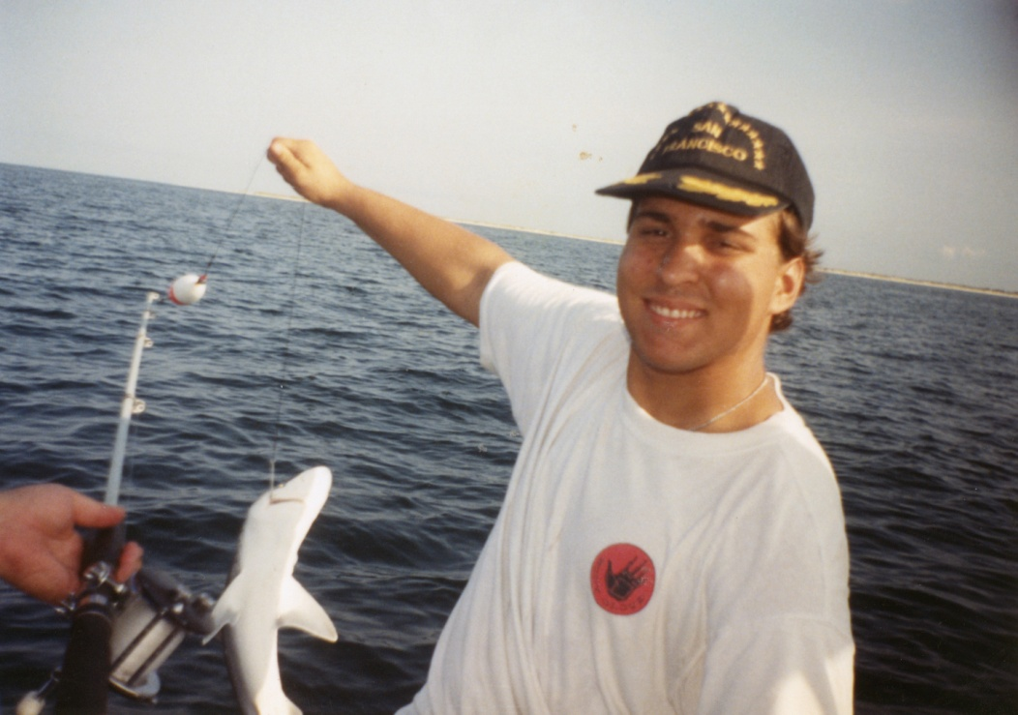
Tony with one of his sharks.

Tortilla Soup

2 diced avocadoes
2 cans Mexican Rotel
1 bunch cilantro
Lime juice
Crushed tortilla chips or Fried tortilla strips
1 fresh tomato, diced
1 fresh poblano pepper (skinned and diced)
1 fresh Spanish onion
1 clove garlic
24 oz chicken stock
1 whole roasted or grilled chicken, meat peeled off and chopped
Sour cream
8 oz jar of salsa

In large pot, cook onion in EVOO with poblano. Add cumin, salt and garlic. Add chicken stock, salsa, tomato, Rotel, and chicken meat. Add cilantro and simmer 45 minutes to 1 hour. Add lime juice to taste. Serve over crushed chips or tortilla strips and top with avocado, cheese, and sour cream.

We can’t print this cookbook without telling the story of my brother’s first attempt at cooking gumbo. I don’t remember what the occasion was, but he wanted to surprise our parents by making homemade gumbo. No Mama Paul’s for him. I went to the grocery with him and the grand total came to something in the neighborhood of $80. Sheesh – Mama Paul exists for a reason. There was okra, shrimp, sausage, broth, and oysters. I wasn’t thrilled about that last part, but I never really liked oysters anyway. He was slaving away at this pot of gumbo though, and then we both noticed that the house smelled funny. It was a bit like low tide at the boat lunch, honestly. We thought maybe the oysters hadn’t been cleaned enough, but that rinsing them off might fix it. So he proceeded with cooking it all up, and then my parents came home. The look on their faces when they smelled dinner was priceless. I think we all ate 2 spoonfuls before our gag reflexes took over. My mom, bless her, divided the leftovers into freezer bags and had them in the refrigerator for all of 2 days before pitching it. The version in here is much better – and stink-free, I promise.

Gumbo

Onion
Bell pepper
Celery
Okra
Flour
EVOO
Butter
Salt
Pepper
Cajun seasoning
Chicken or shrimp stock
Gumbo file (optional)

Either:
Chicken & sausage
Shrimp & crab
Duck & sausage
In a large pot, make a dark roux, using equal parts flour and oil. Add the diced trinity. Add stock and butter (if using seafood or duck combination). If using chicken or duck and sausage, use the chicken stock. If using the seafood combination, use the shrimp stock. Add the meats and season to taste. Let simmer for 45 minutes. Add sliced okra just before serving over cooked rice.

We had to cross the bay bridge to get from the house in Waveland to the boat lunch. On one drive though, the bridge malfunctioned and we were stuck in traffic. I’m one of those people that, as soon as a traffic jam files up, I start to panic and worry about how long we’ll be there, and what will I do if I have to use the bathroom. My brother, however, just got out of the truck and grabbed his fishing pole.
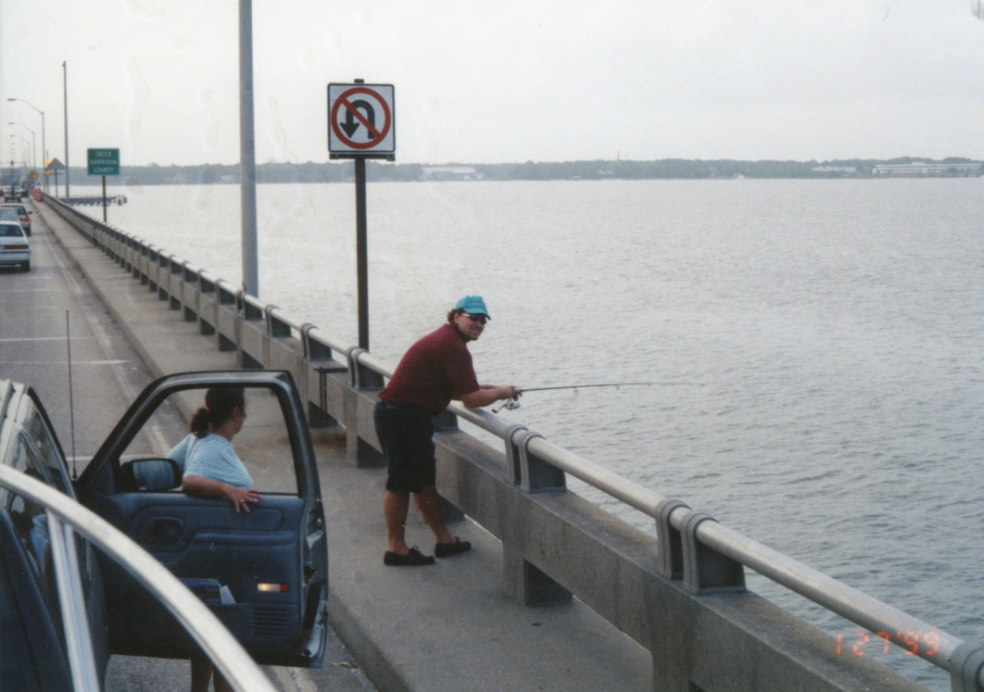

Green Slime*

2 loaves of stale French bread
6 toes garlic
4 onions
4 bell peppers
4 bushels of parsley (as needed, sometimes 3 is enough)
4 stalks of celery
4 cans chicken stock
1 chicken liver
1 chicken heart

Soak bread in water until soft. Drain by hand and either break into pieces or run through a food processor. Run the garlic, onions, bell pepper, celery, and parsley through food processor. Add chicken stock and heat on stove over medium heat for about 30 minutes. Finish by baking in 350 degree oven for approximately 1 hour, checking periodically to make sure it doesn’t dry out.

*This is an unfortunately named (in our family) recipe for holiday dressing. Appearance aside, it is tasty served over turkey and mashed potatoes.

Pulled Pork
Boneless pork shoulder, whatever size desired
Carve diamonds into outside of pork
Smear with thick dark mustard
In small bowl, mix together:
Cumin
Celery seed
Paprika
Garlic powder
Thyme
Basil
Rosemary
Pepper
Salt

Rub combination into meat and grill or smoke until done. Shred into pieces when cooked.

Shrimp Enchiladas

1 lb shrimp
½ cup shrimp stock
Corn tortillas
Enchilada sauce
8 oz grated pepper jack cheese
8 oz grated cheddar cheese
Habanero pepper
Onion
Cumin
1 bunch cilantro
1 clove garlic
Salt & pepper

Peel shrimp and marinate 30 minutes in lime juice and cilantro. To make shrimp stock, boil shells in water.
Cook onion in EVOO with salt & pepper until clear. Add shrimp and cilantro with shrimp stock. Add 1 tablespoon flour to mixture to thicken. Add 1/3 of the cheese combination. Spoon this mixture into tortillas and roll and place in baking dish. Cover with 1/3 cheese and sauce. Place another layer of filled tortillas on top and continue this process until done. Bake in 400 degree oven 10 minutes or until brown and bubbly.

Sonora Dog

Bacon
All beef hot dogs
Sourdough buns
1 can pinto beans, drained
8 oz sour cream
Habanero pepper
Pico de gallo (equal parts green onion and tomato with lime juice)
Radish
Cheddar cheese

Wrap hot dog in bacon and cook on flat iron. Steam sour dough buns and top hot dog as desired with beans, pico de gallo, pepper, etc.

Furniture became a big topic of discussion while he was in rehab. Mom wanted to get him a recliner to sit in so he wouldn’t be in the wheelchair all day. One of the big questions though was what kind of bed could he use? One night we googled “furniture for paraplegics”. Some websites had pictures of hospital beds or beds with railings. I asked him if any of the therapists had mentioned needing railings and he said, “I don’t really kick around in my sleep anymore, you know?”
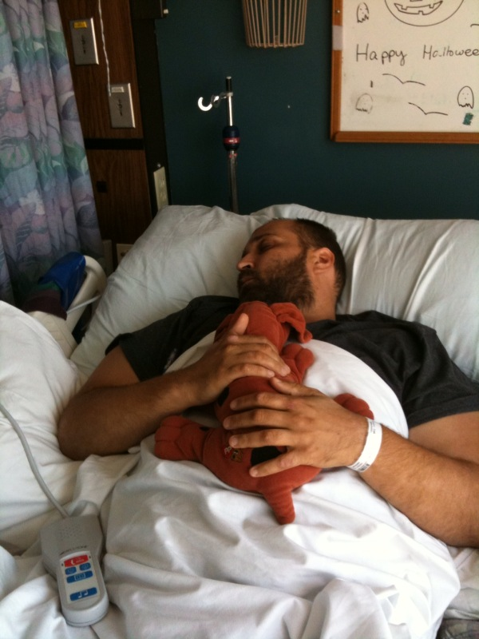
Tony in the hospital with Legs the First.

Chimichangas

12” flour tortilla
Smoked chicken
Combination of equal parts pepper jack and cheddar cheese
Cumin
1 onion
1 bunch cilantro
1 clove garlic
Avocado
Sour cream
Chicken stock
1 can Mexican Rotel
Lime juice
Habanero pepper

Cook down onion with cumin, salt and pepper. Add habanero, stock, and chicken and adjust seasonings. Add Rotel and cilantro, and adjust seasonings again. Simmer until most of the liquid evaporates. Stuff tortilla with mixture and cheese and deep dry in vegetable oil. Serve with more cheese, sour cream, and avocado and be happy.

Yummy McCheesy Toast

Buffalo mozzarella
Fresh basil leaves
French bread
Balsamic vinegar
Salt & Pepper
EVOO
Sliced tomato

Lay out bread, cover with slices of mozzarella cheese, tomato, and basil leave. Sprinkle salt, pepper, EVOO and balsamic vinegar on top and toast bread until cheese is melted.

New Orleans is known for its bars, parties, and Catholics and our parents are no exception. We were at Mass every Sunday, obscenely early on a day we were going fishing (my parents found a 6:00 mass close to a good fishing spot in Mississippi). Somehow my brother and I lost the dedication as teenagers, and we were home free when Tony got his driver’s license. We had this routine going that we thought was just brilliant, but I’m sure Mom and Dad caught on to us at day one. I’m pretty sure that our blank expressions when they asked us what the service was about were a big clue. My brother would drive up to the church near our house, St. Edward’s. I would hop out of the car, run in and grab a bulletin, and we’d drive around for an hour. I loved those rides. I felt so cool, hanging out with my big brother. We’d listen to music – I remember the day he introduced me to this new artist called Marilyn Manson (I was pretty smug when Manson got popular and I could say I’d heard him a long time ago). Sometimes we’d go to Wal-Mart, sometimes we’d just drive around, but it was nice 45 minutes or so together, till we drove back to the church parking lot, and then home when we saw people starting to leave.

Flautas
Place in crock pot
1 beef rump roast, seasoned with cumin, salt, pepper, cayenne pepper and chili powder
2 cans Mexican Rotel
1 chopped habenero pepper
1 chopped tomato
1 chopped onion
2 tbs balsamic vinegar
1 bunch cilantro, chopped
1 clove garlic

Cook on low 4-6 hours. Wrap meat mixture in 12” flour tortilla and deep fry. Serve with sour cream and salsa.

Meatballs

1 onion
½ bell pepper
1 stalk celery
1 cup parmesan cheese
¼ cup pasta sauce
1 lb 80/20 ground beef
1 clove garlic
Italian-style bread crumbs
1 egg
Salt
Pepper

Reduce onion, bell pepper and celery and add to meat in mixing bowl. Combine with parmesan cheese, garlic, tomato sauce and egg. Add bread crumbs to solidify, and a dash of salt and pepper. Shape into balls and simmer in pot of tomato sauce till cooked, at least one hour.

Buscheloni

Veal round
Onion
Bell pepper
1 jar artichoke hearts
Italian-style bread crumbs
Hard-boiled egg
Garlic
Tomato sauce

Pound out veal round until twice original size. Slice and sauté onion and bell pepper in EVOO. Combine on, bell pepper, garlic, bread crumbs, egg, and artichoke hearts to form stuffing. Spoon into middle of veal and roll. Secure with a toothpick and cover with tomato sauce. Bake in 350 degree oven for 20 minutes.

Carne Asada

Beef – round steak or sirloin
Tortillas
Onion
Bell pepper
Garlic
Poblano pepper

Marinate the meat overnight in a mixture of 2 cans of Mexican Rotel, lime juice, balsamic vinegar, chili powder, garlic, paprika, salt, pepper, and a splash of bourbon.
Either grill or cook on high heat in a flat iron.
Slice and fry together the veggies in EVOO and butter.
Cut into strips, and serve on tortillas with sautéed vegetables. Top with a fried egg.

Smoked Chicken
Cherry or pecan wood soaked in water for 2-3 days.
Baste whole chicken with butter, inside and out.
Season with salt, pepper, thyme, oregano, garlic, paprika, and cayenne pepper.
Stuff inside of bird with sage, thyme, rosemary, and basil

Put in smoker until cooked.

Blackened Catfish

Catfish filets
Lemon juice
Blackening Seasoning
Butter
Salt
Pepper

Heat cast iron skillet. Season fish with salt, pepper, and seasoning. Melt butter in hot skillet and cook fish until done. Sprinkle lemon juice before serving.

Ceviche

Lemon juice
Lime juice
EVOO
Tomato
Green Onion
Shrimp
Squid

Dice all vegetables and seafood into small pieces. Cover liberally with EVOO, lemon and lime juice. Let cook in juice and enjoy.

During the second week of rehab, they added recreational therapy to the program. Basically, this was about adapting your previous interests and hobbies to ones that are handicap or wheelchair accessible. He told us that the therapist came in and told him that a group was going to see the Hornets play. But not a real Hornets game, a wheelchair basketball team. Mind you, he’s never been into basketball, or any sport other than the Saints really, so his answer? “I don’t want to watch the Handi Hornets play”. Then they ask him what he is into “Fishing, hunting, anything outside really. “ “Oh, well, how about going to see a movie?” “Why would I want to see a movie, I can sit in here and watch TV if I want to sit in a chair.” “Um... Sometimes we go to the Zoo or the Aquarium”. “That might be fun.” “Actually, let me check on that, because the bus is pretty booked up now. Maybe you can go help in the kitchen once the fixator is off your leg.” I don’t see recreational therapy going very far for my brother.

Hunter’s Stew – Legs’ favorite!!

Aluminum foil
Chicken or Beef chunks
Potato
Onion
Carrot
Peas
Green beans

Chop up potato, onion, and carrot. Put everything in a foil pouch and place on hot coals until cooked.

Sautéed Broccoli
Broccoli
Garlic
Parmesan cheese
EVOO

Chop up head of broccoli. Heat 1 tsp of EVOO in deep skillet, and add broccoli. Stir often until almost cooked and then add the rest of the ingredients.

Pork Explosion
Pork loin
Cajun sausage
Uncooked bacon

Slice pork loin almost in half (longwise) creating a hinge. Partially hollow out inside of loin. Cook Cajun sausage in pan, draining fat. Form a mat by basket-weaving the strips of bacon. Fill the pork loin with sausage and fold back. Roll mat around the pork loin and bake for 45 minutes at 350 degrees.

The external fixator quickly became the bane of my brother’s existence. Basically, it was 2 bars held onto his leg by 4 screws that went into his bone. In true ironic form, the fixator was on his right leg, which is where he has feeling down to his knee. So when an inexperienced nurse would try to help him turn, using the fixator as leverage, there was always much yelling and cursing. His first three days at Touro were basically just the doctors running every test they could think of, so there were a lot of trips down to the X-ray or CAT scan machine. On one of these trips, his right leg slipped and drooped off of the stretcher. This was obviously a bad thing, not just because it was painful, but because the fixator was basically holding his right leg together, as well as the artery that had to be repaired to save his foot. The nurses had to call his doctor, who had a fit and ordered x-rays of the leg. Tony, who by this point was understandably worried about anything else breaking on him, was in a panic all night that his foot would have to be amputated. A week later, he would still ask nurses to check and make sure he still had a pulse in both of his feet. 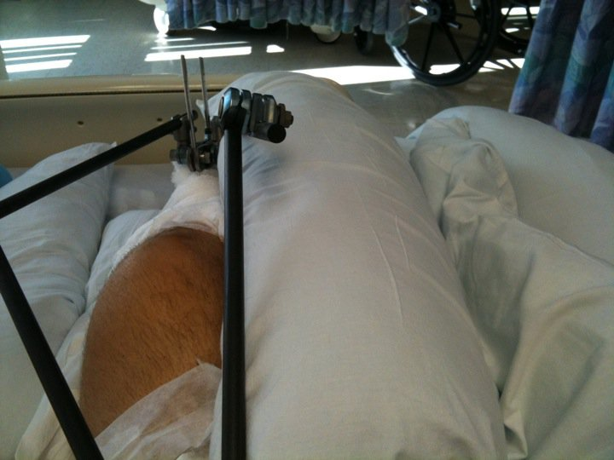

Deer Sausage

Sausage casings
Ground deer meat, approximately 2 ½ lbs
Ground pork meat, ½ lb
Salt
Pepper
Paprika
Cayenne pepper
Garlic, finely chopped
Onion, finely chopped

Mix all together and stuff into casings. Use a sausage rolling machine if available.

Fried Turkey
Turkey fryer
5 gallons of peanut oil heated to 350

Inject bird with Cajun injector seasoning 3 days before cooking. Let sit in a bag in the fridge for 3 days, fry until cooked

Mashed Potatoes
Diced potatoes
Roasted garlic
Salt
Pepper
Heavy cream
Butter

Peel and chop potatoes. Boil and mash. Add rest of ingredients and enjoy

Lo Mein

1 package lo mein noodles
Rice vinegar
Soy sauce
Sunflower seeds
Diced chicken
Onion
Bell pepper
1 egg

Cook noodles per directions, drain and place on side. Coat skillet with EVOO. Cook chicken pieces in skillet with soy sauce and rice vinegar. Chop onion and bell pepper into large pieces and add to skillet. Push veggies and chicken to one side and scramble egg. Add cooked noodles, and soy sauce and rice vinegar to taste.

One of the nice things about the Touro rehab program, and maybe this is true of all rehab facilities, is that they focus on the person as a whole. Tony had a neuro-psychologist assigned that would visit him every day and check on him. His usual reply was “I’m not ready to off myself yet.”
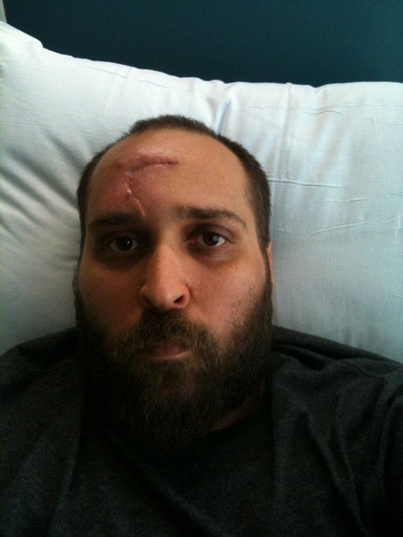

Ribs

All purpose seasoning
Hickory chips

Season meat generously with seasoning and smoke over hickory chips until done.

Dirty Rice

Ground beef
Garlic
Onion
Rice
Butter
Green onion
Salt
Pepper
Cajun seasoning

Cook rice per directions. In a large skillet, cook ground beef with onion and garlic. Add green onion, cooked rice and seasoning.

Apparently muscle spasms are common after a spinal cord injury. To me, this just seems cruel. You can’t use your leg anymore, but we’ll give you painful cramps to remind you of what you can’t do? We would try to stretch his leg or massage the thigh muscles when we visited, but that didn’t always work. He started calling his left leg his “magic” leg. “That’s going to tell me where the fish are and when the hurricanes are coming.” You have to imagine this being said in a “Lieutenant Dan” accent.

Stuffed Bell Peppers, Version 2

1 cup cooked rice
Tomato sauce
Garlic
Crushed tomatoes
1 lb sausage (Italian or Cajun), casing removed
1 lb ground beef
Trinity, diced
Parmesan cheese

Sauce trinity in EVOO. Render Sausage and beef with trinity and garlic. Add tomato sauce and can of crushed tomatoes. Add rice and parmesan cheese. Stuff bell and cover in bread crumbs. Bake at 350 for 45 minutes.

Potato Salad

5 lb potatoes
6 eggs, boiled, peeled, and cut or smashed
Salt
Pepper
Mustard
Mayonnaise
Parsley

Boil potatoes in water until soft. Peel and cut into small pieces. Add rest of ingredients and mix well.

Lasagna
Cooked lasagna noodles
Simple tomato sauce with meat and mushrooms
Ricotta cheese
Mozzarella cheese
Italian sausage, casing removed.

Render sausage and add to meat sauce. Layer noodles with cheeses and tomato sauce, ending with a layer of cheese. Bake at 350 until cheese is brown and bubbly.

Lamb
Rub finely chopped fresh mint, garlic, and EVOO on lamb chop. Sprinkle with salt and pepper. Grill until almost done. Add more rub and cook in oven for last minute.

Grilled Tuna Salad
Tuna steak
Salt
Pepper
Garlic, finely chopped
Salad fixings
Season tuna heavily with salt, pepper and a little garlic

Cook to medium-rare or medium and server over greens.

Nothing was safe when my brother hit his clumsy stage. I should say clumsier stage, because grace and coordination are not really common in our family. Our mom had these German vases that I thought were hideous but they must have had either sentimental or monetary value because she hit the roof when my brother knocked one over and shattered it. At one point she yelled “Why can’t I have anything nice?!” Restaurants weren’t good either, because something would always hit the floor. One time we went to the Waffle House in Bay St. Louis (a family favorite) and as soon as we sat down my dad tipped over his glass of water and said “Ok, something got spilled, can we just eat dinner now?”

Pork Chops
Season chops with a blend of:
Salt
Pepper
Paprika
Mustard seed
White pepper

Sear using cast iron then put in oven at 350 for 15-20 minutes

Duck and Andouille Sausage

¾ ground andouille
¼ ground duck
Onion, finely diced
Garlic, finely diced
Salt
Pepper
White pepper
Paprika
Green onion, diced

Stuff into casing

Curry

Peanuts
Coconut milk
Chicken breast, sliced
Curry Powder
Salt
Pepper
Onion
Bell pepper
Fragrant rice
Peas
Ham, diced

Chop onion and bell pepper into large pieces. Run peanuts through a food processor. Cook veggies in EVOO then add seasoned chicken. Add coconut milk, peas, salt and pepper. Add curry powder. Simmer 30 minutes then server over fragrant rice.

Grandpa’s Spaghetti

Cooked spaghetti
4 ozs each parmesan, Romano, and cheddar, grated
1 jar tomato sauce
1 garlic clove, diced
Butter
1 tomato

Pour cooked and drained noodles into baking dish. Add butter and let cool. When cool, add garlic and ¾ of the cheese blend and mix. Pour sauce over top. Thinly slice tomato and place slices on top of the sauce. Sprinkle remaining cheese over slices. Bake at 350 until heated and cheese melts.

Crabmeat Ravioli

Prep ravioli pasta using pasta rolling machine

Ingredients for filling:
Trinity
Ricotta cheese
Mozzarella cheese
Salt
Pepper
Fresh basil
Dice trinity and cook over medium heat in buttered skillet. Blend with rest of ingredients and fill pasta. Boil in water and cover with desired sauce.

Crab cakes

Trinity, diced
Crabmeat
1 egg
Breadcrumbs
Parmesan cheese
Cajun seasoning

Sautee trinity in EVOO. Combine all ingredients in a mixing bowl. Form into patties and fry in melted butter.

Softshell Crab

Soft shell crab
Flour
Egg
Salt
Pepper
Peanut oil

Clean crab. Mix flour, salt, and pepper in bowl. Break egg in separate bowl. Dip crab in egg, then dredge in flour mixture and deep fry in peanut oil.

For a while, Tony’s nickname was The Inhaler. It was awe-inspiring how much food he could put away. A pack of hot dogs was no problem. Leftovers were unheard of in our house. This was, probably not coincidentally, the time when we went to a lot of buffet restaurants. There was one in Mississippi called Uncle Chester’s. I liked it because you could pay a quarter and get some crackers to feed the catfish (it didn’t occur to me at the time that those were probably the same catfish you saw fried up in buckets on the dinner line).
Uncle Chester’s was a restaurant that could only exist in the South. Everything there was fried – catfish, rabbit, duck, chicken, apples, corn, broccoli. I honestly don’t remember anything baked or broiled. On one of our visits there, Tony made 5 trips back to the buffet line. Yes, that would be 5 plates full of fried foods. He didn’t even make it to the car before he was hurling it back up. I believe that was the last time we went there.

Seafood Boil

Boil seasoned water in large boiling pot with sausage and garlic.
Add potatoes and corn
Boil 15 minutes then add seafood

Rabbit Sauce Piquant

Rabbit
Simple Tomato Sauce recipe
EVOO
Basil leaves
6 pieces garlic

Cut rabbit into pieces and baste with olive oil, basil and garlic. Cook in sauce. Can be served over grits or polenta.
Sauce Option: Add 1X1 square of dark chocolate to sauce while cooking.

Corn & Crab Soup

Trinity
Butter
Corn
Crabmeat
Salt
Pepper
Paprika
Cayenne
EVOO
Heavy cream

Season trinity with salt, pepper, paprika, and cayenne pepper and cook in EVOO. Add corn and let steep until cooked. Add cream and bring to a boil. Re-season to taste and add crab meat.

TIP: Grill corn and remove from husk for extra flavor.

Chicken Risotto Florentine

Salt
Pepper
Risotto
Mushrooms
Spinach
Leftover grilled chicken pieces
Chicken stock

Let spinach thaw. Cook risotto in chicken stock, and add sliced mushrooms and spinach. Add chicken, then salt and pepper to taste. Can also use shrimp instead of chicken.

Cheesy yummy eggplant rolls

Eggplant cut into ¼” strips long-ways
Ricotta cheese
Broccoli florets
Garlic
EVOO

Mix broccoli florets, cut fine, with garlic and ricotta cheese. Hard sauté the eggplant. Spoon cheese mixture on top of eggplant strips and roll up. Microwave 10 seconds to melt the cheese.

Fish & Chips

Vegetable oil
Fish filets (catfish or cod)
Sliced potatoes
In a bowl mix:
Baking powder
Flour
Salt
Pepper
Water (or Guinness)

Form batter and coat fish fillets. Deep fry potatoes and fish. Serve with malt vinegar and ketchup

Baked Turkey
Make brine out of:
Water
Salt
Pepper
Paprika
Cayenne pepper
Bay leaf
Parsley

Make a stuffing of:
Trinity
Bacon or oysters
Chicken stock
Stale corn bread

Brine bird for 24-36 hours. Stuff and bake at 350 until done.

The Monday of Tony’s third week at Touro, he cooked for his recreational therapy class. I was back in Virginia by this point, so Mom and Dad told me about it. They were up at the hospital, actually, for Touro’s family class. The class was basically a rundown of what to expect when your loved one came home from the hospital, and tips on how to help take care of them until they got to a point where they could do things themselves. Anyway, during the class they could smell something cooking and sure enough, it was Tony. He made asparagus, saffron rice, pasta, and angels on horseback. He had some leftover scallops and shrimp so he improvised a sauce for the pasta. He also had leftover bacon, so he crumbled that up and added it to the rice. Mom and Dad said the therapists were impressed that he was able to figure out what to do with the extra ingredients so nothing was wasted.
When I talked to him that night, he was pretty excited because people kept coming in to check out what smelled so good, and everyone had raved about it. “They must have never had asparagus before, because that went first”, he said. Mom and dad were able to scoop up some leftovers, and said he was planning what to cook for the following week. This was one of the days where I felt like everything was going to be alright in the end. Knowing he could still do things he wanted to do, and also that he knew he could do them, was an awesome feeling. Proud is probably the best way to describe it. I was proud of him, not for cooking because I always knew he could do that. I was proud of him for wanting to and for being happy that it had gone well.

Eggrolls

Eggroll wrappers
Oil
Cabbage
Shrimp
Carrot strips
Bean sprouts
Bacon

Steam ingredients together and stuff wrappers. Deep fry in oil.
Variation:
For southwestern eggrolls use Bbq corn, black beans, and Monterey jack cheese

Soft Shell Benedict
Soft shell crab
Egg
Hollandaise sauce with paprika

Fry crab using earlier recipe. Service with poached egg on top covered in Hollandaise sauce.

Pork Rub
Mix in bowl:
Salt
Pepper
Mustard seed
Paprika
Cayenne
Brown sugar
White sugar
Dried Italian herbs
Allspice
Coriander

Rub on pork then smoke or grill

Chicken Marsala

Flour
EVOO
Marsala wine
Mushrooms
Linguini
Onion

Coat chicken in flour and sauté in pan until crispy. Add sliced onions and mushrooms and cook until soft. Pour marsala wine into pan and heat until reduced. Serve over cooked pasta.

German Potato Salad

Salt
Pepper
5 lb potato
5 hard boiled eggs
Green onion
½ lb bacon

Peel and chop potatoes and boil until tender. Dice green onion and mash eggs. Fry bacon until crispy. Mix all together in bowl and add warm bacon fat just before serving.

Flounder with Shrimp Stuffing
Stuffing:
6 tbsp EVOO
1 small onion, finely chopped
2 stalks celery
½ bell pepper
1 lb shrimp, peeled and deveined
¼ shrimp stock
Italian style bread crumbs
Chives
Dill weed
Salt
Cayenne pepper
Fish:
Flounder filets
Butter
Lemon juice
Fresh parsley
Paprika
Pepper

Heat EVOO in a large skillet. Add trinity, sauté until tender. Add shrimp and cook until shrimp turns pink. Add the stock, dill, salt, and cayenne and cook until heated. Add bread crumbs. Spoon stuffing onto each filet and roll. Place in baking dish and sprinkle with butter, lemon juice, and seasonings. Bake at 375 for 20 minutes or until fish is cooked.

One year for his birthday, Tony got an electrical circuit kit. That year for Christmas, we were determined to catch Santa coming out of the chimney, so he rigged up the circuits to set off an alarm when the connecting wire was hit. We stayed up late Christmas Eve, both of us sitting by our doorways waiting to hear the alarm. I remember finally going to bed and telling myself that the alarm would wake me up and I’d be able to get to the den in time to see Santa. We were pretty bummed when we woke up and realized we’d either slept through the alarm or it never went off. Santa did leave us notes that year though, telling us he’d seen us set the trap and made sure to step over the wires.
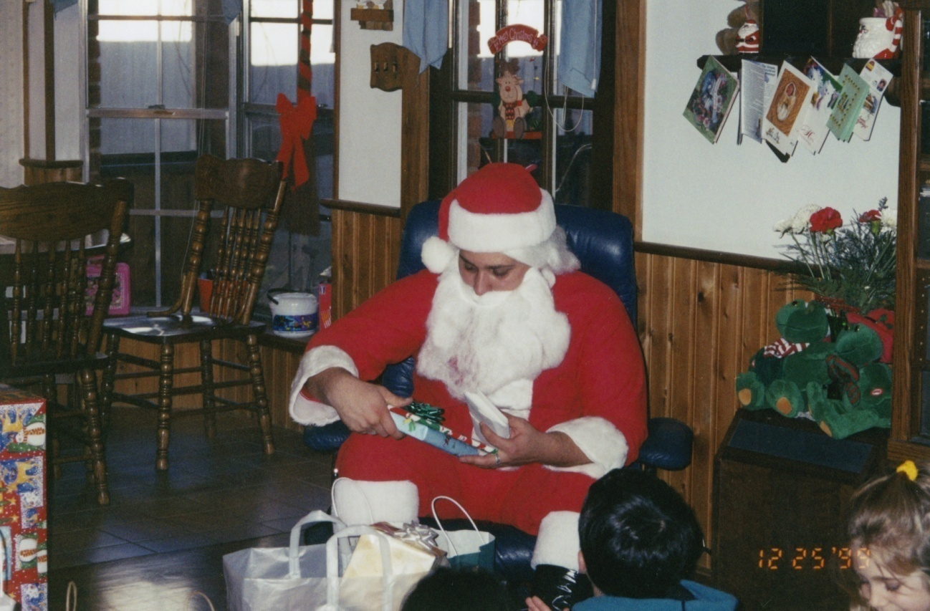
Tony as Santa

Alligator Pie

Dough for shells (empanada shells)
Trinity
Garlic
Tomato sauce
Diced tomato
Gator meat
Rice

Sauté trinity in olive oil then add garlic and alligator meat. Add diced tomato and tomato sauce. Add cooked rice. Lay out the bottoms of the empanada shells and fill with stuffing. Assemble shells and bake at 400 for 20 minutes. You can also deep fry these in peanut oil.

Manicotti

Make thin wide noodles to roll

Make the easy tomato sauce recipe in this book

For manicotti filling:
Ricotta cheese
Diced garlic
Diced artichoke hearts
Broccoli florets cut into small pieces
Roll noodles with filling and place in baking pan. Cover with tomato sauce and mozzarella chesse. Bake at 350 until bubbly.

Cannelloni

Big manicotti noodles, as in previous recipe
Tomato sauce

Filling:
Ground lamb
Ground veal
Ground beef
Diced onion
Garlic
EVOO
Italian seasoning
Brown meat in pan with EVOO, garlic, and Italian seasoning. Stuff noodles with cooked meats and place in pan. Cover with tomato sauce and bake at 350 for 10 minutes.

Asparagus

Asparagus spears
Garlic
EVOO
Balsamic vinegar
Salt
Pepper

Blanche asparagus in salted water
In bowl mix all ingredients and pour over spears. Grilling is the preferred way to cook these or you can broil them until done.

Bone Marrow Butter

Basting liquid consists of:
Garlic
EVOO
Italian Seasoning
Butter

Purchase beef marrow bones from butcher.

Put marrow bones on baking sheet. Combine ingredients for basting liquid in sauce pan and cook on low heat. Let steep then cool. Put cooled liquid on bones. Bake at 350 for 15 minutes. Spoon marrow out of bones and spread on toasted French bread.

Minestrone

Small pasta shells – cooked
Mixed vegetables
Kidney beans
White beans
Trinity
Beef stock
Red wine
Garlic

Cook trinity in olive oil and garlic. Add beef stock and vegetables. Simmer for 15 minutes and add beans and pasta shells. Cook until warm and then serve.

Unfortunately week 3 at Touro did not end well. During the meeting with his doctor, my dad asked about his injured kidney. The team called in a nephrologist and they did an ultrasound and some blood tests. The good news was that the kidney we thought was dead was actually operating, just at reduced rate. The bad news was that they discovered he had a lower sodium rate and were going to hook up to an IV to try to bring it up. They were also going to do some more tests on Monday to see what was really going on with the kidney and if it could be repaired. Tony called me, as frustrated as I’d heard him since all this had started. He didn’t want to be hooked up to an IV, he was upset he’d missed 3 days of rehab (Wednesday when they took the fixator off, Thursday for the doctor’s meeting, and Friday for all of these tests). He didn’t want to miss Monday to do more tests, and he sure as hell didn’t want to have another surgery. He just wanted to finish rehab and go home. He felt like he was regressing instead of moving forward.
I felt terrible because there was nothing I could say. He was right – everything about his situation sucked, and after almost 6 weeks in the hospital, who would want to go back to being on an IV? I was glad he was venting about it though. I’d much rather he get his feelings out then keep everything in and let it fester. I’m not an expert, but I’m sure that’s a healthier way to do things. The scariest part is that this is all new territory. We’ve never gone through anything like this before, so there’s no frame of reference to look at. No one can say, “Oh yes, this is normal and in 6 months things will be peachy again.” It’s terrifying not to know if things will ever even approach normal again. When all you have is hope, faith, and willpower it’s hard not to stumble every once in a while.

Oyster-Choke Soup

Trinity
Red Pepper
Salt
Pepper
Paprika
Cayenne
Cajun seasoning
Diced artichoke hearts
Oysters (cooked)
Heavy cream
Butter
Worcestershire sauce
Thyme
Garlic

Cook trinity in EVOO with garlic and seasonings. Add butter, cream and Worcestershire sauce, Add artichoke hearts and oyster with liquid. Reason and heat until ready to serve.

Chicago Style Italian Sausage

Big Italian sausage
Bell Pepper and onion, julienned
Garlic, diced
Salt
Pepper
Mayo
Honey mustard
Sourdough hot dog buns
Beer

Cook sausage in beer on stove. Sauté bell pepper and onion in EVOO until soft and hot. Put together on bun with mayo and honey mustard.

Meatloaf

2 or 3 hardboiled eggs
1-2 lb ground beef
Tomato sauce
Salt
Pepper
Italian seasoning
Basil
Paprika
Cayenne pepper
Coriander
Lemon zest
Garlic
Parmesan cheese
Egg
Bread crumb

Season ground beef – combine beef with garlic, seasoning, cheese, raw egg, and bread crumb. (Add bread crumb until beef is firm). Cover bottom of loaf pan with beef. Place hard boiled eggs in center and cover with rest of ground beef (eggs should be in the middle of the meatloaf). Cover with tomato sauce. Bake at 325 until cooked, about 45 minutes. Serve with pasta and remainder of tomato sauce.

Mom’s kitchen is legendary in our family. There is the Tupperware cabinet that you can only open at your own risk because the mismatched containers and lids will spill out all over the floor. There’s also the spice cabinet, which apparently has never met an expiration date it couldn’t defy. We mock with great affection, of course.
Dad and Tony went through a hot sausage po-boy phase, where that was all they would order when we went out. One night Tony decided to make some at home, so he sprayed some Pam in a skillet, cooked the sausage up, and served them up. Dad kind of made a face when he was eating his and asked if Tony thought it tasted funny. Tony said no, so Dad asked how he cooked it. Tony explained, and then we noticed that the yellow spray can was not Pam, it was EZ-Off cooking spray. Dad panicked and started reading the can, while Mom called poison control. Tony started yelling at Mom, “Why would you put the EZ-Off with the food??” At least now we know to make sure the labels face frontwards.
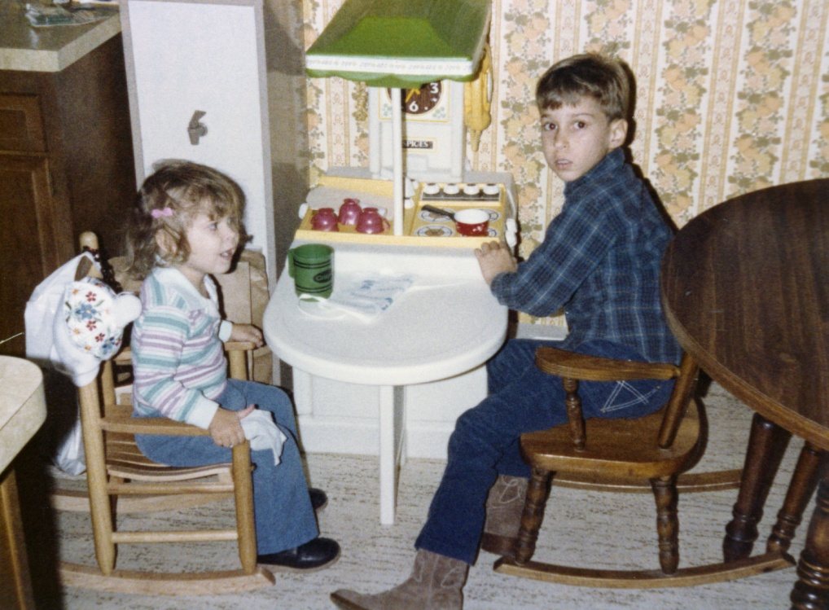
Tony cooking, no EZ-Off here!

